Business Plan

Company
5348 Vegas Drive #816
Las Vegas, Nevada. 89108
972-467-7343
702-552-7672

www.mysite.com
feedback@mysite.com

Confidentiality Agreement
The undersigned reader acknowledges that the information provided by _______________ in this business plan is confidential; therefore, reader agrees not to disclose it without the express written permission of thecompany.
It is acknowledged by reader that information to be furnished in this business plan is in all respects confidential in nature, other than information which is in the public domain through other means and that any disclosure or use of same by reader may cause serious harm or damage to thecompany.
Upon request, this document is to be immediately returned to _______________.
___________________
Signature
___________________
Name (typed or printed)
___________________
Date
This is a business plan. It does not imply an offering of securities.

1.0 Executive Summary 4
1.1 Objectives 5
1.2 Mission 5
1.3 Keys to Success 5
2.0 Company Summary 6
2.1 Company Ownership 7
2.2 Start-up Summary 7
3.0 Products 9
4.0 Market Analysis Summary 9
4.1 Market Segmentation 10
4.2 Target Market Segment Strategy 10
4.3 Competition and Buying Patterns 10
5.0 Strategy and Implementation Summary 11
5.1 Competitive Edge 12
5.2 Marketing Strategy 12
5.3 Sales Strategy 13
5.4 Sales Forecast 14
5.5 Milestones 15
6.0 Web Plan Summary 15
6.1 Development Requirements 16
7.0 Management Summary 16
7.1 Personnel Plan 17
8.0 Financial Plan 20
8.1 Start-up Funding 20
8.2 Financial Assumptions 20
8.3 Break-even Analysis 21
8.4 Operations and Equipment Budget 22
8.5 Projected Profit and Loss 25
8.6 Gross Margins 30
8.7 Projected Cash Flow 32

1.0 Executive Summary
The multi-million dollar M2M industry continues to grow rapidly as blah blah blah.
It is commonly known that even the best selling blah in the marketplace today are poorly engineered: they break easily.
thecompany, Inc. was established in 2015 for the purpose of creating unique and reliable blah products to address this problem. Our products will be distinctive in look and feel, address overlooked consumer needs, and will be higher in quality than competing products due to a higher standard of engineering.
Thecompany team is an experienced world-class marketing and engineering team who has worked together for years creating high volume, quality commercial products such as blah blah. We are excited to be focusing our professional talent on this industry, making quality a priority while adding minimal cost.
thecompany will utilize established distribution and manufacturing channels within the industry for sales and manufacturing. We have been building strong relationships over the past year with key players in these areas.
Initial product lines that thecompany will pursue during the start-up phase will be blah blah focused products and blah products that address the need for blah. We will then expand to address other untapped and future market opportunities.
This is a unique opportunity for investors to tap into this $xx million blah industry.
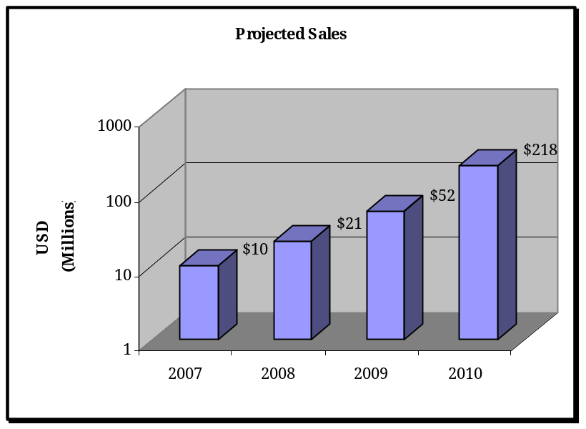
1.1 Objectives
Goals and Priorities:
Secure funding for 20 months of operation to build and market initial products in the blah and blah product lines.
Required Steps:
A. Develop Products
      - Design
      - Tooling
      - File Patents/Trademarks
      - Testing
      - Manufacturing (first 1,000 units)
B. Marketing
      - Marketing collateral
      - Product launch (marketing/advertising)
      - Trade show expenses
C. Operations & Support
      - Personnel
      - Operations
      - Fulfillment

1.2 Mission
thecompany provides unique and reliable products designed explicitly to blah blah. Our products will be creatively distinctive in look and feel, address overlooked consumer needs, and will be higher in quality than competing products due to a higher standard of engineering.

1.3 Keys to Success
- Blah companies – It is important that we are embraced by blah blah companies that demand high quality products and desire new and unique products to sell. The distribution points of the blah channel are in the tens of thousands across the USA. They know their customers personally and depend on satisfied customers for referrals and repeat business, therefore they are careful in their selection of products to promote. blah recently aired a story on February 12, 2006, “Blah” (Bill Wong, Penton Publishing C-ME), where they state “blah blah”
- Quality – We will build our reputation on quality. All products will be built with high quality standards while keeping costs in mind.
- Uniqueness – We will strive to offer innovative and unique products instead of “me too” products to maximize blah blah.
- Tastefulness – Most existing products and packaging in this industry have a reputation for being blah bad blah. Our products and packaging will be less blah and more blah.
- Address ignored markets – We have seen first hand at blah trade shows and seminars that the majority of the top blah manufacturers and distributors are not addressing blah. We have marketing strategies to address the needs of these ignored groups.
- Expand beyond blah market – We can establish larger volume sales by selling blah products into additional markets such as:
      - blah Industry
      - blah related “brick and mortar” blah stores such as blah
      - Shopping magazines such as SkyMall/blah
      - blah magazines
      - Top selling magazines such as blah
    - Educate sales consultants and the consumer – We have learned in our research that sales consultants – both blah and in “brick and mortar stores” – are not receiving adequate training from vendors. We have strategies to educate sales consultants via seminars, web-based FAQ/tutorials, and also through “how to” pamphlets inside product packaging, which will result in mind-share for our products because they are much more effective sales consultants when promoting our products. “How to” pamphlets inside product packaging will also help to educate the consumer so they have a positive experience, come back for repeat business, and refer our products to others.

2.0 Company Summary
thecompany, Inc. was established because we grew tired of hearing about products that were malfunctioning and decided to do something about it.
We will focus on product development, sales, and marketing of blah products, and rely on established distribution channels and manufacturing facilities.
Our products are creatively distinctive in look and feel, address overlooked consumer needs, and will be higher in quality than competing products due to a higher standard of engineering.

2.1 Company Ownership
thecompany, Inc. was founded in April 2005 as a Texas Corporation. Current Officers/Management includes:
- Don Powrie, President/CEO
- Jesse Lee, CTO
- blah?
The Officers currently own 100% of the company.

2.2 Start-up Summary
- Obtain $x million in investment funding for first 20 months of operation.
- Staffing - fill positions as needed over first 16 months.
- Develop first eight products in the blah product lines.
- Establish sales channel agreements with the top six blah.
- Establish quality manufacturing channels.
- Establish additional advertising channels (e.g., magazines and web-based).
- Continue to establish contacts within the blah industry.
- Continue attending trade shows to fine-tune marketing strategies.
- Launch first three product lines at a major trade show within first xx months.
- Launch second set of at least three additional product lines at or before month 19.

EXPENSES | TTL Y1 | TTL Y2 | TTL Y3
Rent (10K/ft2 Building--see notes 1-5 below) | $180,000 | $180,000 | $180,000
Utilities ($3000 elec+gas+etc.) | $36,000 | $36,000 | $36,000
Telecommunications (Cell, DSL, IP, analog) | $18,000 | $18,000 | $18,000
LAN wiring/build-out ($200/drop) | $4,000 | $0 | $0
Web Site Design (consultants) | $50,000 | $20,000 | $20,000
E-Commerce Site Design (consultants) | $15,000 | $10,000 | $10,000
Insurance (comp/liability/bldg) (see note 7) | $96,000 | $96,000 | $96,000
Legal/Audit (see note 12) | $60,000 | $60,000 | $60,000
Engineering Prototype Expenses | $22,000 | $24,000 | $24,000
Trade Shows (see notes 8 and 9) | $9,300 | $84,000 | $126,000
Trade Show Entertainment | $1,500 | $24,000 | $36,000
General Travel (4 trips/month, 2 days each) | $57,600 | $57,600 | $57,600
Advertising | $60,000 | $600,000 | $720,000
Property/School Taxes (estimated only) | $30,000 | $35,000 | $40,000
Other Assorted Expenses (see note 10) | $15,000 | $15,000 | $15,000
TOTAL EXPENSES | 654,400 | $1,259,600 | $1,438,600

EQUIPMENT (incl. Software) | TTL Y1 | TTL Y2 | TTL Y3
Desks/Partitions/Furniture ($1250/head) | $27,500 | $5,000 | $0
Computers (average $3500 ea) (see note 6) | $77,000 | $14,000 | $0
ERP Server | $5,000 | $0 | $0
E-Commerce Server | $5,000 | $0 | $0
Routers/Firewall/Printers/UPS/etc. | $13,000 | $0 | $0
Pro-E Design Software (CAD) (see note 11) | $36,000 | $5,400 | $5,400
ERP Software (see note 11) | $50,000 | $7,500 | $7,500
Trade Show Booth | $15,000 | $0 | $0
Engineering Proto Lab | $15,000 | $0 | $0
Injection Molding Tools ($80K/tool) | $400,000 | $480,000 | $480,000
Phone System | $12,000 | $0 | $0
Warehouse Shelving/Fixtures/Equipment | $10,000 | $0 | $0
TOTAL EQUIPMENT | $665,500 | $511,900 | $492,900

Cost of Goods Sold (GOGS) | TTL Y1 | TTL Y2 | TTL Y3
GOGS | $490,218 | $4,517,898 | $8,083,854
Total GOGS | $490,218 | $4,517,898 | $8,083,854

Assumptions:
1. Pallet size = 40"x48"x48" (92160in^3); average product size is 8"x5"x2" (80in^3). This makes each pallet hold on the order of 1200 pcs. Estimating 50,000 pieces in inventory at any one time, we need 42 pallets worth of storage. Note: we can go with 2x deep pallets but then we'll need a forklift. 42 pallets with 8' access space (3.5'x(4'+12')) is approx. 2500 sqft. for just finished goods.
2. Need approx. 200sqft per person for office space (includes build out for common areas). For 20 people this is 4000sqft.
3. Need approx 1000sqft for staging/shipping.
4. Need approx 500sqft for engineering proto lab/machine shop.
5. 10,000sqft building leaves 2000sqft for growth.
6. Sales and marketing guys are issued laptops. Design Engineers are issued workstations.
7. Estimate.
8. Travel per person includes: $500 air, $100/day meals, $200/day hotel, $50/day transportation.
9. For trade shows: 10x20 booth @$10,000 + $2000 promotional items, 4 people attending for 5 days.
10. Subscriptions, office supplies, etc.
11. Include yearly maintenance fee of 15%.
12. This is an estimate, assuming $250/hr for 20 hr/month. Also includes Accounting/Audit functions.

3.0 Products
There are two initial product lines that thecompany will pursue during the start-up phase of the company: blah focused and blah products:
The blah product line:
The blah will aid blah to experience blah. The general population is increasingly becoming aware of blah. thecompany's new blah product line is timely in that blah is one of the hottest new trends in the industry. Our products have a significantly different angle than anything else on the market and are specifically designed to blah. Our prototype/proof-of-concept device has been well received by a test group of blah. Packaging for the device will be blah, to generate interest from the non-traditional blah. Additional design work will focus on making the units aesthetically pleasing, easy-to-use, and blah. Pricing for the blah will be around $90.00.
The blah product line:
Many would-be-buyers are blah blah. Our blah product line alleviates this problem because our blah product line does not blah. Our blah products can also be marketed outside the blah Industry which will allow for higher sales volumes; giving us greater economies of scale (see marketing section). Packaging for the devices will be blah, to generate interest from the non-traditional blah buyer. Products will range from $15.00 - $150.00.

4.0 Market Analysis Summary
The blah Industry has been one of the largest industries in the world. Increased blah awareness due to sources such as the Internet, television, and rising mainstream acceptance of blah are fuelling the industry’s growth rate. According to a recent study conducted by blah blah in 2005, 43 percent of blah. It is estimated that annual sales of blah products in the USA are around $500M and the total worldwide sales are estimated to be around $14.3B (Marc blah. “The Power of blah.” blah Guest Commentaries & News: March 7, 2006; blah). blah News, the leading trade publication for the blah industry, recently reported that sales of blah have increased by a staggering 25 percent or more each of the past few years.

4.1 Market Segmentation
the company will target all segments of the population blah, whether it be blah, blah, blah, blah, blah, blah.
The quality of the products, packaging and how we will advertise to these groups will satisfy each segment. It will be a blah, welcomed alternative to the existing blah that are available to these markets.
Key initial target segments will be:
- blah – This market is growing and their interest in blah products has been openly discussed in current articles and news programs.
- blah – This market is growing because blah are becoming more comfortable with blah. Just like blah, the blah segment can be reached through blah, by making it blah while having blah. Ultimately they’ll gain more knowledge about blah so that their blah blah are more successful.
- blah - About 4 million people are " blah," according to estimates by the blah and other researchers. This is a great group to market to that will also be valuable to gain research information.
4.2 Target Market Segment Strategy
The strategy behind thecompany target segmentation is to attract customers who want to blah and blah. thecompany wants to position the product by initially targeting our audience through blah. This will allow the consumer to feel comfortable by being with others who blah.

4.3 Competition and Buying Patterns
The following are three products that, in our opinion, stand above others on the market; yet we have seen first hand that even these high-end products still lack either quality or features that the consumer desires:
blah
There are various blah in the market. The blah is one of the most unique and popular blah in this category.
Strengths – It is different looking than all other blah and the blah are the most popular amongst blah.
Weaknesses – Some customers commented that the blah is not blah enough and looks intimidating. blah is too blah and there have been reports of blah.
The blah and most other blah on the market today don’t correctly blah. Our blah focused product lines are blah designed to provide the blah.

blah
The blah is one of the few blah in the market.
Strengths – Creative idea, good power from two AAA batteries, blah. blah
Weaknesses – Very noisy and not blah (reports of batteries corroding). Only one blah and it is not intuitive where the blah is located. We ordered two blah and one of them arrived broken in the package – the blah had broken off of the base of the device, and there is no way to open it up to repair it.

blah
The blah and similar looking blah are the most popular and innovative in the market.
Strengths – Good power, great job of its blah and is well known because of hype on the HBO series blah”. Many different blah and patterns.
Weakness – It is too blah and blah. Under normal use it is prone to malfunctioning and falling apart. There have been reports of battery covers coming off during use. There is no locking function so it is easy to accidentally blah or change settings during use.

5.0 Strategy and Implementation Summary
Our sales and marketing strategy will be a combination of targeted mass-marketing techniques, including print and internet-based advertising, and through industry trade shows. We will establish reasonable sales strategies for key markets, along with an implementation plan designed to ensure that our goals are achieved.

5.1 Competitive Edge
Our management team consists of a group of highly professional and successful business people with engineering backgrounds. With this talent set we will bring quality and business savvy that is often lacking in this industry.
    - Quality – We will build our reputation on quality. All products will be built with high quality standards while keeping costs in mind.
    - Uniqueness – We will strive to offer innovative and unique products instead of “me too” products to maximize blah.
    - Tastefulness – Most existing products and packaging in this industry have a reputation for being too blah. Our products and packaging will be less blah.
    - Education of sales consultants and the consumer – We have strategies to educate sales consultants via seminars, web-based FAQ/tutorials, and also through “how to” pamphlets inside product packaging, which will result in mindshare for our products because they are much more effective sales consultants when promoting our products. “How to” pamphlets inside product packaging will also help to educate the consumer so they have a positive experience, come back for repeat business, and refer our products to others.

5.2 Marketing Strategy
Our marketing initiatives include:
- blah. The number of blah Sales Consultants has grown to tens of thousands blah across the country. They primarily rely on word of mouth networking through their customers in order to grow their business, so product reliability is extremely important to them.
Most blah are held in the blah, where the host invites blah.
Many blah companies are forced to go through a middleman distributor, so we can achieve higher margins and greater market share if we sell to these companies directly and offer an on-line process for order replenishing.
- Website. Creation of our enhanced website with the capability for registered distribution channels to login for order replenishment.
- Trade Shows. Thecompany will participate in select national and international shows that will provide an opportunity to increase exposure. This is a very effective marketing tool in creating awareness and stimulating lead activity.
- Industry Organizations and Associations. thecompany will strive to become members of key worldwide organizations that are relevant to this industry as a whole. This initiative will create awareness of the company within the industry, and provide networking opportunities.
- Advertising. We will attend select trade shows to increase product awareness, create humorous online commercials that will be sent by electronic mail to individuals, and provide advertisement material for use by blah companies. Ads will also be placed in blah magazines and blah magazines such as SkyMall.
- Expanding to Other Markets. Expand to other markets such as: Latin America, Canada, Australia, and Europe, utilizing established distribution channels in those markets.

5.3 Sales Strategy
Our sales strategy is to work with established sales channels to generate and close leads, educate prospects, fill needs and satisfy wants of consumers appropriately, and therefore turn prospective customers into actual customers.
- blah Companies. Sales will be accomplished at blah by experienced and well trained associates, utilizing their product knowledge to show the best aspects of our products, and practicing basic transaction skills to close the sale.
- blah. Sales will be gained in this market by organizing events with blah who will be hosting the blah gathering.
- blah. Sales will be gained in this market by organizing events with blah and affiliated companies.
- blah. Sales will be accomplished by sponsoring events held at their location and through advertising on blah organization websites.
- Trade Shows. blah sales consultants and “brick-and-mortar” owners attend key national and international blah trade shows, seeking the latest products. thecompany will participate in select national and international shows that will provide an opportunity to increase exposure.
- Brick-and-mortar Stores. There are over 20,000 brick-and-mortar blah stores across the country, many of which are adding their own on-line stores. Training material and sales incentives for store employees will be key to obtaining mindshare and increasing sales of blah products.
- Non- blah Retail Channels. Our blah product lines will also be sold through various non- blah industry retail channels such as blah and blah stores; sporting venues; blah and shopping magazines, etc. This will allow for greater economies of scale.

5.4 Sales Forecast
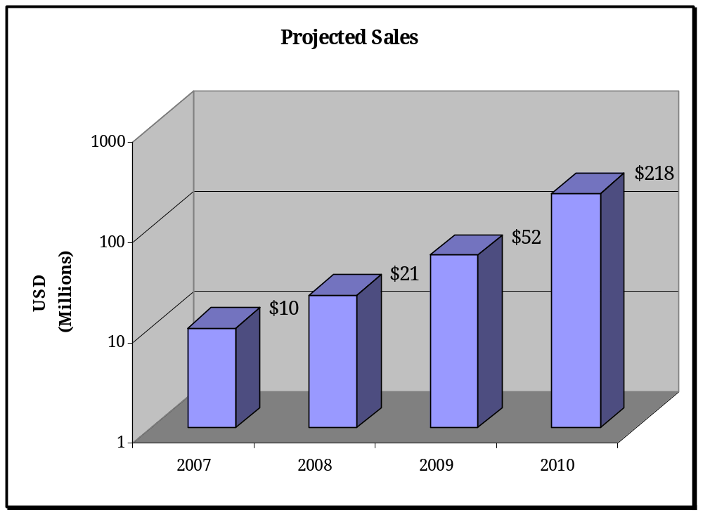

Projected Unit Forecast
Product Line | 2006 | 2007 | 2008 | 2009 | 2010
GS (High End) | 0 | 75,000 | 101,250 | 126,563 | 253,125
DL (High End) | 0 | 27,500 | 74,250 | 92,813 | 185,625
DL (Low End) | 0 | 0 | 114,750 | 143,438 | 286,875
SPO (High End) | 0 | 75,000 | 101,250 | 126,563 | 253,125
SPO (Low End) | 0 | 0 | 128,250 | 160,313 | 320,625
SPH (High End) | 0 | 17,500 | 47,250 | 59,063 | 118,125
SPH (Medium End) | 0 | 65,000 | 87,750 | 109,688 | 219,375
SPH (Low End) | 0 | 0 | 117,563 | 146,954 | 293,908
PL9-PL18 (10 new products) | 0 | 0 | 0 | 778,000 | 1,556,000
PL19-PL30 (12 new products) | 0 | 0 | 0 | 0 | 1,300,000
Acquired products (25 or more) | 0 | 0 | 0 | 0 | 2,500,000
Total | 0 | 260,000 | 772,313 | 1,743,391 | 7,286,783

The sales forecast is based upon the following assumptions:
- Three product lines are introduced in July 2007, followed by at least two more in January 2008, followed by three feature-reduced product lines in June 2008.
- Our entry into the market is through the blah channel. There is an estimated 21,000 independent salespeople at the top five blah companies. We assume that each can sell at least one per month.
- We anticipate "copycat" products from other vendors; therefore we plan to introduce feature-reduced product families one year after our high feature products are introduced, to maintain ASPs of our high feature products and establish low feature, low cost points for cost sensitive consumers.
- By the year 2009, we expect to have a strong sales presence also in the blah related markets such as sporting venues, blah stores, etc.
- By the year 2010, we expect to have a strong sales presence in additional markets, such as Latin America, Canada, Australia, and Europe, utilizing established distribution channels in those markets.
- By the year 2010, we expect to acquire select competing and complimentary companies.
- We estimate that as we establish world-wide name brand recognition and a good reputation due to our innovative and quality products, these run rates will turn out to be extremely conservative.

5.5 Milestones
The first phase of products will be launched at the blah Expo in blah during the month of July 2007. For this launch we will have the following in place:
- Product developed, patented, tested and in production
- Sufficient inventory for blah corporate orders
- Product collateral
- Website
- Tradeshow booth, advertising slots in select trade magazines, press releases, etc.

6.0 Web Plan Summary
thecompany will create a website that is blah and blah that people can visit to obtain product information. Retailers (blah consultants, brick-and-mortar and online retail store owners/clerks, etc) can log in with a user name and password to obtain marketing and training tools, and order product through our E-Commerce system.

6.1 Development Requirements
Initially the web site will be hosted by a full-service provider with prepackaged e-commerce capabilities. Since our product line is (initially) fairly limited, this should keep the recurring fees fairly low. The actual web site development will be outsourced to a reputable design house.

7.0 Management Summary
Our management team has extensive engineering and management experience that will be used for the development and sales of our products:
CEO/President: Mr. Powrie has blah blah bio blah blah

CTO/Chief Engineer: Mr. Lee has more than 21 years of professional experience in blah blah bio blah blah

7.1 Personnel Plan
Personnel Salary Requirements with Staging Dates
Job Title/Function (occupant) | Year 1  Salary | 1 | 2 | 3 | 4 | 5 | 6 | 7 | 8 | 9 | 10 | 11 | 12 | Year 1 Actual  Salary
CEO/President () | $140,000 | $11,667 | $11,667 | $11,667 | $11,667 | $11,667 | $11,667 | $11,667 | $11,667 | $11,667 | $11,667 | $11,667 | $11,667 | $140,000
CMO/VP Sales () | $140,000 | $11,667 | $11,667 | $11,667 | $11,667 | $11,667 | $11,667 | $11,667 | $11,667 | $11,667 | $11,667 | $11,667 | $11,667 | $140,000
COO () | $140,000 | $11,667 | $11,667 | $11,667 | $11,667 | $11,667 | $11,667 | $11,667 | $11,667 | $11,667 | $11,667 | $11,667 | $11,667 | $140,000
CTO/Chief Engineer () | $140,000 | $11,667 | $11,667 | $11,667 | $11,667 | $11,667 | $11,667 | $11,667 | $11,667 | $11,667 | $11,667 | $11,667 | $11,667 | $140,000
CFO/Controller | $130,000 |  |  |  |  |  |  |  |  |  |  |  | $10,833 | $10,833
Marketing Director | $130,000 |  | $10,833 | $10,833 | $10,833 | $10,833 | $10,833 | $10,833 | $10,833 | $10,833 | $10,833 | $10,833 | $10,833 | $119,167
Market Research Analyst () | $45,000 | $3,750 | $3,750 | $3,750 | $3,750 | $3,750 | $3,750 | $3,750 | $3,750 | $3,750 | $3,750 | $3,750 | $3,750 | $45,000
Marketing Project Coordinator | $45,000 |  |  |  |  |  |  |  |  |  | $3,750 | $3,750 | $3,750 | $11,250
Marketing Communications Coordinator | $65,000 |  |  |  |  | $5,417 | $5,417 | $5,417 | $5,417 | $5,417 | $5,417 | $5,417 | $5,417 | $43,333
Sales #1 (base salary only) | $60,000 |  |  |  |  |  |  |  | $5,000 | $5,000 | $5,000 | $5,000 | $5,000 | $25,000
Sales #2 (base salary only) | $60,000 |  |  |  |  |  |  |  | $5,000 | $5,000 | $5,000 | $5,000 | $5,000 | $25,000
Sales #3 (base salary only)
Sales #4 (base salary only)
Design Engineer #1 | $75,000 |  |  | $6,250 | $6,250 | $6,250 | $6,250 | $6,250 | $6,250 | $6,250 | $6,250 | $6,250 | $6,250 | $62,500
Design Engineer #2 | $75,000 |  |  |  |  | $6,250 | $6,250 | $6,250 | $6,250 | $6,250 | $6,250 | $6,250 | $6,250 | $50,000
Design Engineer #3
Quality Assurance | $50,000 |  |  |  |  |  | $4,167 | $4,167 | $4,167 | $4,167 | $4,167 | $4,167 | $4,167 | $29,167
Artist #1 | $45,000 |  | $3,750 | $3,750 | $3,750 | $3,750 | $3,750 | $3,750 | $3,750 | $3,750 | $3,750 | $3,750 | $3,750 | $41,250
Artist #2 | $45,000 |  | $3,750 | $3,750 | $3,750 | $3,750 | $3,750 | $3,750 | $3,750 | $3,750 | $3,750 | $3,750 | $3,750 | $41,250
IT/Network Administrator | $60,000 |  | $5,000 | $5,000 | $5,000 | $5,000 | $5,000 | $5,000 | $5,000 | $5,000 | $5,000 | $5,000 | $5,000 | $55,000
Operations Supervisor | $45,000 |  |  |  | $3,750 | $3,750 | $3,750 | $3,750 | $3,750 | $3,750 | $3,750 | $3,750 | $3,750 | $33,750
Shipping/Receiving Supervisor | $35,000 |  |  |  |  | $2,917 | $2,917 | $2,917 | $2,917 | $2,917 | $2,917 | $2,917 | $2,917 | $23,333
Shipping/Receiving Clerk #1 | $25,000 |  |  |  |  |  |  |  | $2,083 | $2,083 | $2,083 | $2,083 | $2,083 | $10,417
Shipping/Receiving Clerk #2 | $25,000 |  |  |  |  |  |  |  |  |  |  | $2,083 | $2,083 | $4,167
Shipping/Receiving Clerk #3 | $25,000
Purchasing Agent | $55,000 |  |  | $4,583 | $4,583 | $4,583 | $4,583 | $4,583 | $4,583 | $4,583 | $4,583 | $4,583 | $4,583 | $45,833
Bookkeeper | $33,000 | $2,750 | $2,750 | $2,750 | $2,750 | $2,750 | $2,750 | $2,750 | $2,750 | $2,750 | $2,750 | $2,750 | $2,750 | $2,750
TOTAL |  | $53,167 | $76,500 | $87,333 | $91,083 | $105,667 | $109,833 | $109,833 | $121,917 | $121,917 | $125,667 | $127,750 | $138,583 | $1,239,000
TOTAL with 35% Labor Burden |  | $71,775 | $103,275 | $117,900 | $122,963 | $142,650 | $148,275 | $148,275 | $164,588 | $164,588 | $169,650 | $172,463 | $187,088 | $1,672,650
NUMBER OF PERSONNEL |  | 6 | 10 | 12 | 13 | 16 | 17 | 17 | 20 | 20 | 21 | 22 | 23

Personnel Salary Requirements with Staging Dates
Job Title/Function (occupant) | Year 2  Salary | 13 | 14 | 15 | 16 | 17 | 18 | 19 | 20 | 21 | 22 | 23 | 24 | Year 2 Actual  Salary
CEO/President () | $150,000 | $12,500 | $12,500 | $12,500 | $12,500 | $12,500 | $12,500 | $12,500 | $12,500 | $12,500 | $12,500 | $12,500 | $12,500 | $150,000
CMO/VP Sales () | $150,000 | $12,500 | $12,500 | $12,500 | $12,500 | $12,500 | $12,500 | $12,500 | $12,500 | $12,500 | $12,500 | $12,500 | $12,500 | $150,000
COO () | $150,000 | $12,500 | $12,500 | $12,500 | $12,500 | $12,500 | $12,500 | $12,500 | $12,500 | $12,500 | $12,500 | $12,500 | $12,500 | $150,000
CTO/Chief Engineer () | $150,000 | $12,500 | $12,500 | $12,500 | $12,500 | $12,500 | $12,500 | $12,500 | $12,500 | $12,500 | $12,500 | $12,500 | $12,500 | $150,000
CFO/Controller | $140,000 | $11,667 | $11,667 | $11,667 | $11,667 | $11,667 | $11,667 | $11,667 | $11,667 | $11,667 | $11,667 | $11,667 | $11,667 | $140,000
Marketing Director | $136,500 | $11,375 | $11,375 | $11,375 | $11,375 | $11,375 | $11,375 | $11,375 | $11,375 | $11,375 | $11,375 | $11,375 | $11,375 | $136,500
Market Research Analyst () | $47,250 | $3,938 | $3,938 | $3,938 | $3,938 | $3,938 | $3,938 | $3,938 | $3,938 | $3,938 | $3,938 | $3,938 | $3,938 | $47,250
Marketing Project Coordinator | $47,250 | $3,938 | $3,938 | $3,938 | $3,938 | $3,938 | $3,938 | $3,938 | $3,938 | $3,938 | $3,938 | $3,938 | $3,938 | $47,250
Marketing Communications Coordinator | $68,250 | $5,688 | $5,688 | $5,688 | $5,688 | $5,688 | $5,688 | $5,688 | $5,688 | $5,688 | $5,688 | $5,688 | $5,688 | $68,250
Sales #1 (base salary only) | $63,000 | $5,250 | $5,250 | $5,250 | $5,250 | $5,250 | $5,250 | $5,250 | $5,250 | $5,250 | $5,250 | $5,250 | $5,250 | $63,000
Sales #2 (base salary only) | $63,000 | $5,250 | $5,250 | $5,250 | $5,250 | $5,250 | $5,250 | $5,250 | $5,250 | $5,250 | $5,250 | $5,250 | $5,250 | $63,000
Sales #3 (base salary only) | $63,000 |  |  | $5,250 | $5,250 | $5,250 | $5,250 | $5,250 | $5,250 | $5,250 | $5,250 | $5,250 | $5,250 | $52,500
Sales #4 (base salary only) | $63,000 |  |  | $5,250 | $5,250 | $5,250 | $5,250 | $5,250 | $5,250 | $5,250 | $5,250 | $5,250 | $5,250 | $52,500
Design Engineer #1 | $78,750 | $6,563 | $6,563 | $6,563 | $6,563 | $6,563 | $6,563 | $6,563 | $6,563 | $6,563 | $6,563 | $6,563 | $6,563 | $78,750
Design Engineer #2 | $78,750 | $6,563 | $6,563 | $6,563 | $6,563 | $6,563 | $6,563 | $6,563 | $6,563 | $6,563 | $6,563 | $6,563 | $6,563 | $78,750
Design Engineer #3 | $78,750 |  |  | $6,563 | $6,563 | $6,563 | $6,563 | $6,563 | $6,563 | $6,563 | $6,563 | $6,563 | $6,563 | $65,625
Quality Assurance | $52,500 | $4,375 | $4,375 | $4,375 | $4,375 | $4,375 | $4,375 | $4,375 | $4,375 | $4,375 | $4,375 | $4,375 | $4,375 | $52,500
Artist #1 | $47,250 | $3,938 | $3,938 | $3,938 | $3,938 | $3,938 | $3,938 | $3,938 | $3,938 | $3,938 | $3,938 | $3,938 | $3,938 | $47,250
Artist #2 | $47,250 | $3,938 | $3,938 | $3,938 | $3,938 | $3,938 | $3,938 | $3,938 | $3,938 | $3,938 | $3,938 | $3,938 | $3,938 | $47,250
IT/Network Administrator | $63,000 | $5,250 | $5,250 | $5,250 | $5,250 | $5,250 | $5,250 | $5,250 | $5,250 | $5,250 | $5,250 | $5,250 | $5,250 | $63,000
Operations Supervisor | $47,250 | $3,938 | $3,938 | $3,938 | $3,938 | $3,938 | $3,938 | $3,938 | $3,938 | $3,938 | $3,938 | $3,938 | $3,938 | $47,250
Shipping/Receiving Supervisor | $36,750 | $3,063 | $3,063 | $3,063 | $3,063 | $3,063 | $3,063 | $3,063 | $3,063 | $3,063 | $3,063 | $3,063 | $3,063 | $36,750
Shipping/Receiving Clerk #1 | $26,250 | $2,188 | $2,188 | $2,188 | $2,188 | $2,188 | $2,188 | $2,188 | $2,188 | $2,188 | $2,188 | $2,188 | $2,188 | $26,250
Shipping/Receiving Clerk #2 | $26,250 | $2,188 | $2,188 | $2,188 | $2,188 | $2,188 | $2,188 | $2,188 | $2,188 | $2,188 | $2,188 | $2,188 | $2,188 | $26,250
Shipping/Receiving Clerk #3 | $26,250 |  |  | $2,188 | $2,188 | $2,188 | $2,188 | $2,188 | $2,188 | $2,188 | $2,188 | $2,188 | $2,188 | $21,875
Purchasing Agent | $57,750 | $4,813 | $4,813 | $4,813 | $4,813 | $4,813 | $4,813 | $4,813 | $4,813 | $4,813 | $4,813 | $4,813 | $4,813 | $57,750
Bookkeeper | $34,650 | $2,888 | $2,888 | $2,888 | $2,888 | $2,888 | $2,888 | $2,888 | $2,888 | $2,888 | $2,888 | $2,888 | $2,888 | $34,650
TOTAL |  | $146,804 | $146,804 | $166,054 | $166,054 | $166,054 | $166,054 | $166,054 | $166,054 | $166,054 | $166,054 | $166,054 | $166,054 | $1,954,150
TOTAL with 35% Labor Burden |  | $198,186 | $198,186 | $224,173 | $224,173 | $224,173 | $224,173 | $224,173 | $224,173 | $224,173 | $224,173 | $224,173 | $224,173 | $2,638,103
NUMBER OF PERSONNEL |  | 23 | 23 | 27 | 27 | 27 | 27 | 27 | 27 | 27 | 27 | 27 | 27

Personnel Salary Requirements with Staging Dates
Job Title/Function (occupant) | Year 3  Salary | 25 | 26 | 27 | 28 | 29 | 30 | 31 | 32 | 33 | 34 | 35 | 36 | Year 3 Actual  Salary
CEO/President () | $170,000 | $14,167 | $14,167 | $14,167 | $14,167 | $14,167 | $14,167 | $14,167 | $14,167 | $14,167 | $14,167 | $14,167 | $14,167 | $170,000
CMO/VP Sales () | $170,000 | $14,167 | $14,167 | $14,167 | $14,167 | $14,167 | $14,167 | $14,167 | $14,167 | $14,167 | $14,167 | $14,167 | $14,167 | $170,000
COO () | $170,000 | $14,167 | $14,167 | $14,167 | $14,167 | $14,167 | $14,167 | $14,167 | $14,167 | $14,167 | $14,167 | $14,167 | $14,167 | $170,000
CTO/Chief Engineer () | $170,000 | $14,167 | $14,167 | $14,167 | $14,167 | $14,167 | $14,167 | $14,167 | $14,167 | $14,167 | $14,167 | $14,167 | $14,167 | $170,000
CFO/Controller | $150,000 | $12,500 | $12,500 | $12,500 | $12,500 | $12,500 | $12,500 | $12,500 | $12,500 | $12,500 | $12,500 | $12,500 | $12,500 | $150,000
Marketing Director | $143,325 | $11,944 | $11,944 | $11,944 | $11,944 | $11,944 | $11,944 | $11,944 | $11,944 | $11,944 | $11,944 | $11,944 | $11,944 | $143,325
Market Research Analyst () | $49,613 | $4,134 | $4,134 | $4,134 | $4,134 | $4,134 | $4,134 | $4,134 | $4,134 | $4,134 | $4,134 | $4,134 | $4,134 | $49,613
Marketing Project Coordinator | $49,613 | $4,134 | $4,134 | $4,134 | $4,134 | $4,134 | $4,134 | $4,134 | $4,134 | $4,134 | $4,134 | $4,134 | $4,134 | $49,613
Marketing Communications Coordinator | $71,663 | $5,972 | $5,972 | $5,972 | $5,972 | $5,972 | $5,972 | $5,972 | $5,972 | $5,972 | $5,972 | $5,972 | $5,972 | $71,663
Sales #1 (base salary only) | $66,150 | $5,513 | $5,513 | $5,513 | $5,513 | $5,513 | $5,513 | $5,513 | $5,513 | $5,513 | $5,513 | $5,513 | $5,513 | $66,150
Sales #2 (base salary only) | $66,150 | $5,513 | $5,513 | $5,513 | $5,513 | $5,513 | $5,513 | $5,513 | $5,513 | $5,513 | $5,513 | $5,513 | $5,513 | $66,150
Sales #3 (base salary only) | $66,150 | $5,513 | $5,513 | $5,513 | $5,513 | $5,513 | $5,513 | $5,513 | $5,513 | $5,513 | $5,513 | $5,513 | $5,513 | $66,150
Sales #4 (base salary only) | $66,150 | $5,513 | $5,513 | $5,513 | $5,513 | $5,513 | $5,513 | $5,513 | $5,513 | $5,513 | $5,513 | $5,513 | $5,513 | $66,150
Design Engineer #1 | $82,688 | $6,891 | $6,891 | $6,891 | $6,891 | $6,891 | $6,891 | $6,891 | $6,891 | $6,891 | $6,891 | $6,891 | $6,891 | $82,688
Design Engineer #2 | $82,688 | $6,891 | $6,891 | $6,891 | $6,891 | $6,891 | $6,891 | $6,891 | $6,891 | $6,891 | $6,891 | $6,891 | $6,891 | $82,688
Design Engineer #3 | $82,688 | $6,891 | $6,891 | $6,891 | $6,891 | $6,891 | $6,891 | $6,891 | $6,891 | $6,891 | $6,891 | $6,891 | $6,891 | $82,688
Quality Assurance | $55,125 | $4,594 | $4,594 | $4,594 | $4,594 | $4,594 | $4,594 | $4,594 | $4,594 | $4,594 | $4,594 | $4,594 | $4,594 | $55,125
Artist #1 | $49,613 | $4,134 | $4,134 | $4,134 | $4,134 | $4,134 | $4,134 | $4,134 | $4,134 | $4,134 | $4,134 | $4,134 | $4,134 | $49,613
Artist #2 | $49,613 | $4,134 | $4,134 | $4,134 | $4,134 | $4,134 | $4,134 | $4,134 | $4,134 | $4,134 | $4,134 | $4,134 | $4,134 | $49,613
IT/Network Administrator | $66,150 | $5,513 | $5,513 | $5,513 | $5,513 | $5,513 | $5,513 | $5,513 | $5,513 | $5,513 | $5,513 | $5,513 | $5,513 | $66,150
Operations Supervisor | $49,613 | $4,134 | $4,134 | $4,134 | $4,134 | $4,134 | $4,134 | $4,134 | $4,134 | $4,134 | $4,134 | $4,134 | $4,134 | $49,613
Shipping/Receiving Supervisor | $38,588 | $3,216 | $3,216 | $3,216 | $3,216 | $3,216 | $3,216 | $3,216 | $3,216 | $3,216 | $3,216 | $3,216 | $3,216 | $38,588
Shipping/Receiving Clerk #1 | $27,563 | $2,297 | $2,297 | $2,297 | $2,297 | $2,297 | $2,297 | $2,297 | $2,297 | $2,297 | $2,297 | $2,297 | $2,297 | $27,563
Shipping/Receiving Clerk #2 | $27,563 | $2,297 | $2,297 | $2,297 | $2,297 | $2,297 | $2,297 | $2,297 | $2,297 | $2,297 | $2,297 | $2,297 | $2,297 | $27,563
Shipping/Receiving Clerk #3 | $27,563 | $2,297 | $2,297 | $2,297 | $2,297 | $2,297 | $2,297 | $2,297 | $2,297 | $2,297 | $2,297 | $2,297 | $2,297 | $27,563
Purchasing Agent | $60,638 | $5,053 | $5,053 | $5,053 | $5,053 | $5,053 | $5,053 | $5,053 | $5,053 | $5,053 | $5,053 | $5,053 | $5,053 | $60,638
Bookkeeper | $36,383 | $3,032 | $3,032 | $3,032 | $3,032 | $3,032 | $3,032 | $3,032 | $3,032 | $3,032 | $3,032 | $3,032 | $3,032 | $36,383
TOTAL |  | $178,774 | $178,774 | $178,774 | $178,774 | $178,774 | $178,774 | $178,774 | $178,774 | $178,774 | $178,774 | $178,774 | $178,774 | $2,145,283
TOTAL with 35% Labor Burden |  | $241,344 | $241,344 | $241,344 | $241,344 | $241,344 | $241,344 | $241,344 | $241,344 | $241,344 | $241,344 | $241,344 | $241,344 | $2,896,131
NUMBER OF PERSONNEL | 26 | 27 | 27 | 27 | 27 | 27 | 27 | 27 | 27 | 27 | 27 | 27 | 27

8.0 Financial Plan
Our Financial Plan is broken out as follows (see section 8.1 – 8.5):

8.1 Start-up Funding
Our total start-up costs will be $5,000,000, as detailed in the Start-up Table in section 2.2. We are expecting to raise this capital via a private equity placement. Kickstarter?

8.2 Financial Assumptions
There are three primary underlying assumptions of our financial plan. Specifically, these include:
- We assume access to equity capital and financing to support this financial plan.
- All financials are based on the worst-case scenario, i.e., minimum sales vs. highest expenses. Our expectations are significantly higher than what has been presented in the plan.
- We also assume there will not be a significant economic crash or currency crisis (i.e., USD vs. Chinese RMB) that would cause our Cost Of Goods to skyrocket. Because of the target market, even with a minor economic setback, we would still expect to sell our products and services, although at lower margins.

8.3 Break-Even Analysis
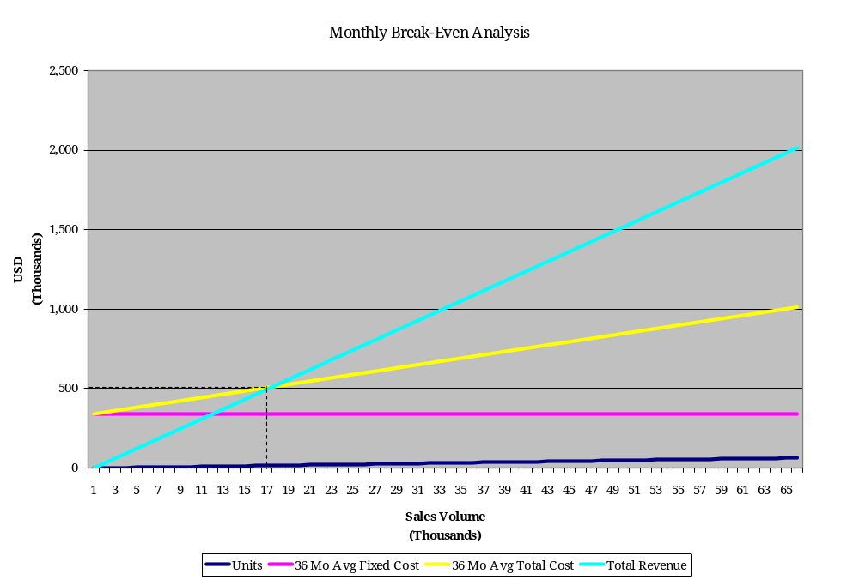
8.4 Operations & Equipment Budget
Monthly Operations & Equipment Budget
EXPENSES | 1 | 2 | 3 | 4 | 5 | 6 | 7 | 8 | 9 | 10 | 11 | 12 | TTL Y1
Rent (10K/ft2 Building) | $15,000 | $15,000 | $15,000 | $15,000 | $15,000 | $15,000 | $15,000 | $15,000 | $15,000 | $15,000 | $15,000 | $15,000 | $180,000
Utilities ($3000 elec+gas+etc.) | $3,000 | $3,000 | $3,000 | $3,000 | $3,000 | $3,000 | $3,000 | $3,000 | $3,000 | $3,000 | $3,000 | $3,000 | $36,000
Telecommunications (Cell, DSL, IP, analog) | $1,500 | $1,500 | $1,500 | $1,500 | $1,500 | $1,500 | $1,500 | $1,500 | $1,500 | $1,500 | $1,500 | $1,500 | $18,000
LAN wiring/build-out ($200/drop) | $4,000 |  |  |  |  |  |  |  |  |  |  |  | $4,000
Web Site Design (consultants) |  | $10,000 | $10,000 | $10,000 | $10,000 | $5,000 |  |  |  |  | $5,000 |  | $50,000
E-Commerce Site Design (consultants) |  | $10,000 |  |  |  |  |  | $5,000 |  |  |  |  | $15,000
Insurance (comp/liability/bldg) | $8,000 | $8,000 | $8,000 | $8,000 | $8,000 | $8,000 | $8,000 | $8,000 | $8,000 | $8,000 | $8,000 | $8,000 | $96,000
Legal/Audit | $5,000 | $5,000 | $5,000 | $5,000 | $5,000 | $5,000 | $5,000 | $5,000 | $5,000 | $5,000 | $5,000 | $5,000 | $60,000
Engineering Prototype Expenses |  | $2,000 | $2,000 | $2,000 | $2,000 | $2,000 | $2,000 | $2,000 | $2,000 | $2,000 | $2,000 | $2,000 | $22,000
Trade Shows | $3,100 |  |  |  |  |  | $6,200 |  |  |  |  |  | $9,300
Trade Show Entertainment | $500 |  |  |  |  |  | $1,000 |  |  |  |  |  | $1,500
General Travel (4 trips/month, 2 days each) | $4,800 | $4,800 | $4,800 | $4,800 | $4,800 | $4,800 | $4,800 | $4,800 | $4,800 | $4,800 | $4,800 | $4,800 | $57,600
Advertising |  |  |  |  |  |  | $30,000 |  |  |  |  | $30,000 | $60,000
Property/School Taxes (estimated only) |  |  |  |  |  |  |  |  |  |  |  | $30,000 | $30,000
Other Assorted Expenses | $1,250 | $1,250 | $1,250 | $1,250 | $1,250 | $1,250 | $1,250 | $1,250 | $1,250 | $1,250 | $1,250 | $1,250 | $15,000
TOTAL EXPENSES | $46,150 | $60,550 | $50,550 | $50,550 | $50,550 | $45,550 | $77,750 | $45,550 | $40,550 | $40,550 | $45,550 | $100,550 | $654,400
EQUIPMENT (incl. Software) | 1 | 2 | 3 | 4 | 5 | 6 | 7 | 8 | 9 | 10 | 11 | 12 | TTL Y1
Desks/Partitions/Furniture ($1250/head) | $7,500 | $5,000 | $2,500 | $1,250 | $3,750 | $1,250 | $0 | $3,750 | $0 | $1,250 | $1,250 | $1,250 | $28,750
Computers (average $3500 ea) | $21,000 | $14,000 | $7,000 | $3,500 | $10,500 | $3,500 | $0 | $10,500 | $0 | $3,500 | $3,500 | $3,500 | $80,500
ERP Server |  | $5,000 |  |  |  |  |  |  |  |  |  |  | $5,000
E-Commerce Server |  | $5,000 |  |  |  |  |  |  |  |  |  |  | $5,000
Routers/Firewall/Printers/UPS/etc. |  | $13,000 |  |  |  |  |  |  |  |  |  |  | $13,000
Pro-E Design Software (CAD) | $36,000 |  |  |  |  |  |  |  |  |  |  |  | $36,000
ERP Software |  | $50,000 |  |  |  |  |  |  |  |  |  |  | $50,000
Trade Show Booth |  |  |  | $15,000 |  |  |  |  |  |  |  |  | $15,000
Engineering Proto Lab |  | $15,000 |  |  |  |  |  |  |  |  |  |  | $15,000
Injection Molding Tools ($80K/tool) |  |  |  | $80,000 |  | $80,000 |  | $80,000 |  | $80,000 |  | $80,000 | $400,000
Phone System | $12,000 |  |  |  |  |  |  |  |  |  |  |  | $12,000
Warehouse Shelving/Fixtures/Equipment |  |  | $10,000 |  |  |  |  |  |  |  |  |  | $10,000
TOTAL EQUIPMENT | $76,500 | $107,000 | $19,500 | $99,750 | $14,250 | $84,750 | $0 | $94,250 | $0 | $84,750 | $4,750 | $84,750 | $670,250

Monthly Operations & Equipment Budget
EXPENSES | 13 | 14 | 15 | 16 | 17 | 18 | 19 | 20 | 21 | 22 | 23 | 24 | TTL Y2
Rent (10K/ft2 Building) | $15,000 | $15,000 | $15,000 | $15,000 | $15,000 | $15,000 | $15,000 | $15,000 | $15,000 | $15,000 | $15,000 | $15,000 | $180,000
Utilities ($3000 elec+gas+etc.) | $3,000 | $3,000 | $3,000 | $3,000 | $3,000 | $3,000 | $3,000 | $3,000 | $3,000 | $3,000 | $3,000 | $3,000 | $36,000
Telecommunications (Cell, DSL, IP, analog) | $1,500 | $1,500 | $1,500 | $1,500 | $1,500 | $1,500 | $1,500 | $1,500 | $1,500 | $1,500 | $1,500 | $1,500 | $18,000
LAN wiring/build-out ($200/drop) |  |  |  |  |  |  |  |  |  |  |  |  | $0
Web Site Design (consultants) |  | $5,000 |  |  | $5,000 |  |  | $5,000 |  |  | $5,000 |  | $20,000
E-Commerce Site Design (consultants) |  | $5,000 |  |  |  |  |  |  | $5,000 |  |  |  | $10,000
Insurance (comp/liability/bldg) | $8,000 | $8,000 | $8,000 | $8,000 | $8,000 | $8,000 | $8,000 | $8,000 | $8,000 | $8,000 | $8,000 | $8,000 | $96,000
Legal/Audit | $5,000 | $5,000 | $5,000 | $5,000 | $5,000 | $5,000 | $5,000 | $5,000 | $5,000 | $5,000 | $5,000 | $5,000 | $60,000
Engineering Prototype Expenses | $2,000 | $2,000 | $2,000 | $2,000 | $2,000 | $2,000 | $2,000 | $2,000 | $2,000 | $2,000 | $2,000 | $2,000 | $24,000
Trade Shows | $21,000 | $21,000 |  |  | $21,000 |  |  | $21,000 |  |  |  |  | $84,000
Trade Show Entertainment | $6,000 | $6,000 |  |  | $6,000 |  |  | $6,000 |  |  |  |  | $24,000
General Travel (4 trips/month, 2 days each) | $4,800 | $4,800 | $4,800 | $4,800 | $4,800 | $4,800 | $4,800 | $4,800 | $4,800 | $4,800 | $4,800 | $4,800 | $57,600
Advertising | $30,000 | $30,000 | $30,000 | $30,000 | $60,000 | $60,000 | $60,000 | $60,000 | $60,000 | $60,000 | $60,000 | $60,000 | $600,000
Property/School Taxes (estimated only) |  |  |  |  |  |  |  |  |  |  |  | $35,000 | $35,000
Other Assorted Expenses | $1,250 | $1,250 | $1,250 | $1,250 | $1,250 | $1,250 | $1,250 | $1,250 | $1,250 | $1,250 | $1,250 | $1,250 | $15,000
TOTAL EXPENSES | $97,550 | $107,550 | $70,550 | $70,550 | $132,550 | $100,550 | $100,550 | $132,550 | $105,550 | $100,550 | $105,550 | $135,550 | $1,259,600
EQUIPMENT (incl. Software) | 13 | 14 | 15 | 16 | 17 | 18 | 19 | 20 | 21 | 22 | 23 | 24 | TTL Y2
Desks/Partitions/Furniture ($1250/head) | $0 | $0 | $5,000 | $0 | $0 | $0 | $0 | $0 | $0 | $0 | $0 | $0 | $5,000
Computers (average $3500 ea) | $0 | $0 | $14,000 | $0 | $0 | $0 | $0 | $0 | $0 | $0 | $0 | $0 | $14,000
ERP Server |  |  |  |  |  |  |  |  |  |  |  |  | $0
E-Commerce Server |  |  |  |  |  |  |  |  |  |  |  |  | $0
Routers/Firewall/Printers/UPS/etc. |  |  |  |  |  |  |  |  |  |  |  |  | $0
Pro-E Design Software (CAD) | $5,400 |  |  |  |  |  |  |  |  |  |  |  | $5,400
ERP Software | $7,500 |  |  |  |  |  |  |  |  |  |  |  | $7,500
Trade Show Booth |  |  |  |  |  |  |  |  |  |  |  |  | $0
Engineering Proto Lab |  |  |  |  |  |  |  |  |  |  |  |  | $0
Injection Molding Tools ($80K/tool) |  | $80,000 |  | $80,000 |  | $80,000 |  | $80,000 |  | $80,000 |  | $80,000 | $480,000
Phone System |  |  |  |  |  |  |  |  |  |  |  |  | $0
Warehouse Shelving/Fixtures/Equipment |  |  |  |  |  |  |  |  |  |  |  |  | $0
TOTAL EQUIPMENT | $12,900 | $80,000 | $19,000 | $80,000 | $0 | $80,000 | $0 | $80,000 | $0 | $80,000 | $0 | $80,000 | $511,900

Monthly Operations & Equipment Budget
EXPENSES | 25 | 26 | 27 | 28 | 29 | 30 | 31 | 32 | 33 | 34 | 35 | 36 | TTL Y3
Rent (10K/ft2 Building) | $15,000 | $15,000 | $15,000 | $15,000 | $15,000 | $15,000 | $15,000 | $15,000 | $15,000 | $15,000 | $15,000 | $15,000 | $180,000
Utilities ($3000 elec+gas+etc.) | $3,000 | $3,000 | $3,000 | $3,000 | $3,000 | $3,000 | $3,000 | $3,000 | $3,000 | $3,000 | $3,000 | $3,000 | $36,000
Telecommunications (Cell, DSL, IP, analog) | $1,500 | $1,500 | $1,500 | $1,500 | $1,500 | $1,500 | $1,500 | $1,500 | $1,500 | $1,500 | $1,500 | $1,500 | $18,000
LAN wiring/build-out ($200/drop) |  |  |  |  |  |  |  |  |  |  |  |  | $0
Web Site Design (consultants) |  | $5,000 |  |  | $5,000 |  |  | $5,000 |  |  | $5,000 |  | $20,000
E-Commerce Site Design (consultants) |  | $5,000 |  |  |  |  |  |  | $5,000 |  |  |  | $10,000
Insurance (comp/liability/bldg) | $8,000 | $8,000 | $8,000 | $8,000 | $8,000 | $8,000 | $8,000 | $8,000 | $8,000 | $8,000 | $8,000 | $8,000 | $96,000
Legal/Audit | $5,000 | $5,000 | $5,000 | $5,000 | $5,000 | $5,000 | $5,000 | $5,000 | $5,000 | $5,000 | $5,000 | $5,000 | $60,000
Engineering Prototype Expenses | $2,000 | $2,000 | $2,000 | $2,000 | $2,000 | $2,000 | $2,000 | $2,000 | $2,000 | $2,000 | $2,000 | $2,000 | $24,000
Trade Shows | $21,000 | $21,000 |  |  |  | $21,000 | $21,000 |  |  |  | $21,000 | $21,000 | $126,000
Trade Show Entertainment | $6,000 | $6,000 |  |  |  | $6,000 | $6,000 |  |  |  | $6,000 | $6,000 | $36,000
General Travel (4 trips/month, 2 days each) | $4,800 | $4,800 | $4,800 | $4,800 | $4,800 | $4,800 | $4,800 | $4,800 | $4,800 | $4,800 | $4,800 | $4,800 | $57,600
Advertising | $60,000 | $60,000 | $60,000 | $60,000 | $60,000 | $60,000 | $60,000 | $60,000 | $60,000 | $60,000 | $60,000 | $60,000 | $720,000
Property/School Taxes (estimated only) |  |  |  |  |  |  |  |  |  |  |  | $40,000 | $40,000
Other Assorted Expenses | $1,250 | $1,250 | $1,250 | $1,250 | $1,250 | $1,250 | $1,250 | $1,250 | $1,250 | $1,250 | $1,250 | $1,250 | $15,000
TOTAL EXPENSES | $127,550 | $137,550 | $100,550 | $100,550 | $105,550 | $127,550 | $127,550 | $105,550 | $105,550 | $100,550 | $132,550 | $167,550 | $1,438,600
 | YEAR 3
EQUIPMENT (incl. Software) | 25 | 26 | 27 | 28 | 29 | 30 | 31 | 32 | 33 | 34 | 35 | 36 | TTL Y3
Desks/Partitions/Furniture ($1250/head) | -$1,250 | $1,250 | $0 | $0 | $0 | $0 | $0 | $0 | $0 | $0 | $0 | $0 | $0
Computers (average $3500 ea) | -$3,500 | $3,500 | $0 | $0 | $0 | $0 | $0 | $0 | $0 | $0 | $0 | $0 | $0
ERP Server |  |  |  |  |  |  |  |  |  |  |  |  | $0
E-Commerce Server |  |  |  |  |  |  |  |  |  |  |  |  | $0
Routers/Firewall/Printers/UPS/etc. |  |  |  |  |  |  |  |  |  |  |  |  | $0
Pro-E Design Software (CAD) | $5,400 |  |  |  |  |  |  |  |  |  |  |  | $5,400
ERP Software (see note 11) | $7,500 |  |  |  |  |  |  |  |  |  |  |  | $7,500
Trade Show Booth |  |  |  |  |  |  |  |  |  |  |  |  | $0
Engineering Proto Lab |  |  |  |  |  |  |  |  |  |  |  |  | $0
Injection Molding Tools ($80K/tool) |  | $80,000 |  | $80,000 |  | $80,000 |  | $80,000 |  | $80,000 |  | $80,000 | $480,000
Phone System |  |  |  |  |  |  |  |  |  |  |  |  | $0
Warehouse Shelving/Fixtures/Equipment |  |  |  |  |  |  |  |  |  |  |  |  | $0
TOTAL EQUIPMENT | $8,150 | $84,750 | $0 | $80,000 | $0 | $80,000 | $0 | $80,000 | $0 | $80,000 | $0 | $80,000 | $492,900

Operations Assumptions:
- Payroll: High payroll costs are associated with using the company founders for doing the majority of initial design engineering, product production planning, promotion, and marketing functions.
- Payroll Burden: Includes payroll taxes, medical and dental insurance, 401K plan contributions and management (for all employees).
- Rent: 10,000 square feet of flex space (50% office/50% air-conditioned warehouse) at $18/ft2.
  - This assumes a 3-year lease.
  - Pallet size = 40"x48"x48" (92160in^3); average product size is 8"x5"x2" (80in^3). This makes each pallet hold on the order of 1200 pcs. Estimating 50,000 pieces in inventory at any one time, we need 42 pallets worth of storage. Note: we can go with 2x deep pallets but then we'll need a forklift. 42 pallets with 8' access space (3.5'x(4'+12')) is approx. 2500 sqft. for just finished goods.
  - Need approx. 200sqft per person for office space (includes build out for common areas). For 20 people this is 4000sqft.
  - Need approx 1000sqft for staging/shipping.
  - Need approx 500sqft for engineering proto lab/machine shop.
  - 10,000sqft building leaves 2000sqft for growth.
- Utilities: Includes security service, gas, electric, water.
- Telecommunications and Web Site: Includes land line, fax, and two cellular phones for company use. Web site will be hosted by a quality ISP and will include a built-in e-commerce package.
- Computer Equipment Leases: Computers/printers/networking equipment to run the company. Sales and marketing guys are issued laptops. Design Engineers are issued workstations.
- Software Licenses: Covers ERP, Pro-E Design, Office, and other software expenses. Include yearly maintenance fee of 15%.
- Insurance: Includes General Business and Liability.
- Legal: Specialized legal assistance with respect to manufacturing products for the blah blah Industry. Assumes $250/hr for 20 hr/month. Also includes Accounting/Audit functions.
- Tooling Expenses: Specialized consulting services for tooling design and manufacturing.
- Marketing/Promotion: Print & online advertising.
- Travel and Entertainment: Travel expenses includes customer visits and travel to Mexico and China (where the products will be manufactured).
- Trade Show Expenses: Covers trade show expenses such as floor space, registration, & setup fees, travel expenses, etc). $50/day transportation. 10x20 booth @$10,000 + $2000 promotional items, 4 people attending for 5 days. Travel per person includes: $500 air, $100/day meals, $200/day hotel,
- Trade Show Booth Expense: Covers the design and construction of a booth that can be re-used at multiple trade shows.
8.5 Projected Profit and Loss

Monthly Profit/Loss Analysis
 |  | 1 | 2 | 3 | 4 | 5 | 6 | 7 | 8 | 9 | 10 | 11 | 12
LABOR
Salaries with  35% Labor Burden |  | $71,775 | $103,275 | $117,900 | $122,963 | $142,650 | $148,275 | $148,275 | $164,588 | $164,588 | $169,650 | $172,463 | $187,088
OPERATIONS
Equipment |  | $76,500 | $107,000 | $19,500 | $99,750 | $14,250 | $84,750 | $0 | $94,250 | $0 | $84,750 | $4,750 | $84,750
Expenses |  | $46,150 | $60,550 | $50,550 | $50,550 | $50,550 | $45,550 | $77,750 | $45,550 | $40,550 | $40,550 | $45,550 | $100,550
COGS |  |  |  |  |  |  |  |  |  |  |  | $245,109 | $245,109
TOTAL EXPENSES  (PAYABLES) |  | $194,425 | $270,825 | $187,950 | $273,263 | $207,450 | $278,575 | $226,025 | $304,388 | $205,138 | $294,950 | $467,872 | $617,497
SALES FORECAST |  | $0 | $0 | $0 | $0 | $0 | $0 | $0 | $0 | $0 | $0 | $0 | $0
RECEIVABLES |  | $0 | $0 | $0 | $0 | $0 | $0 | $0 | $0 | $0 | $0 | $0 | $0
MONTHLY  PROFIT/LOSS |  | -$194,425 | -$270,825 | -$187,950 | -$273,263 | -$207,450 | -$278,575 | -$226,025 | -$304,388 | -$205,138 | -$294,950 | -$467,872 | -$617,497
CASH FLOW | $5,000,000 | $4,805,575 | $4,534,750 | $4,346,800 | $4,073,538 | $3,866,088 | $3,587,513 | $3,361,488 | $3,057,100 | $2,851,963 | $2,557,013 | $2,089,141 | $1,471,644
Note: Assumes 60 day delay on payment after sales recorded on books.

Monthly Profit/Loss Analysis
 | 13 | 14 | 15 | 16 | 17 | 18 | 19 | 20 | 21 | 22 | 23 | 24
LABOR
Salaries with  35% Labor Burden | $198,186 | $198,186 | $198,186 | $224,173 | $224,173 | $224,173 | $224,173 | $224,173 | $224,173 | $224,173 | $224,173 | $224,173
OPERATIONS
Equipment | $12,900 | $80,000 | $19,000 | $80,000 | $0 | $80,000 | $0 | $80,000 | $0 | $80,000 | $0 | $80,000
Expenses | $97,550 | $107,550 | $70,550 | $70,550 | $132,550 | $100,550 | $100,550 | $132,550 | $105,550 | $100,550 | $105,550 | $135,550
COGS | $245,109 | $245,109 | $245,109 | $245,109 | $379,124 | $379,124 | $379,124 | $379,124 | $379,124 | $379,124 | $589,062 | $673,655
TOTAL EXPENSES  (PAYABLES) | $553,745 | $630,845 | $558,832 | $619,832 | $735,847 | $783,847 | $703,847 | $815,847 | $708,847 | $783,847 | $918,785 | $1,113,378
SALES FORECAST | $735,327 | $735,327 | $735,327 | $735,327 | $735,327 | $735,327 | $1,137,373 | $1,137,373 | $1,137,373 | $1,137,373 | $1,137,373 | $1,137,373
RECEIVABLES | $0 | $0 | $735,327 | $735,327 | $735,327 | $735,327 | $735,327 | $735,327 | $1,137,373 | $1,137,373 | $1,137,373 | $1,137,373
MONTHLY  PROFIT/LOSS | -$553,745 | -$630,845 | $176,495 | $115,495 | -$520 | -$48,520 | $31,480 | -$80,520 | $428,525 | $353,525 | $218,588 | $23,995
CASH FLOW | $917,900 | $287,055 | $463,550 | $579,045 | $578,525 | $530,004 | $561,484 | $480,964 | $909,489 | $1,263,015 | $1,481,602 | $1,505,598
Note: Assumes 60 day delay on payment after sales recorded on books.

Monthly Profit/Loss Analysis
 | 25 | 26 | 27 | 28 | 29 | 30 | 31 | 32 | 33 | 34 | 35 | 36
LABOR
Salaries with  35% Labor Burden | $241,344 | $241,344 | $241,344 | $241,344 | $241,344 | $241,344 | $241,344 | $241,344 | $241,344 | $241,344 | $241,344 | $241,344
OPERATIONS
Equipment | $8,150 | $84,750 | $0 | $80,000 | $0 | $80,000 | $0 | $80,000 | $0 | $80,000 | $0 | $80,000
Expenses | $127,550 | $137,550 | $100,550 | $100,550 | $105,550 | $127,550 | $127,550 | $105,550 | $105,550 | $100,550 | $132,550 | $167,550
COGS | $673,655 | $673,655 | $673,655 | $673,655 | $673,655 | $673,655 | $673,655 | $673,655 | $673,655 | $673,655 | $673,655 | $673,655
TOTAL EXPENSES  (PAYABLES) | $1,050,699 | $1,137,299 | $1,015,549 | $1,095,549 | $1,020,549 | $1,122,549 | $1,042,549 | $1,100,549 | $1,020,549 | $1,095,549 | $1,047,549 | $1,162,549
SALES FORECAST | $1,767,186 | $2,020,964 | $2,020,964 | $2,020,964 | $2,020,964 | $2,020,964 | $2,020,964 | $2,020,964 | $2,020,964 | $2,020,964 | $2,020,964 | $2,020,964
RECEIVABLES | $1,137,373 | $1,137,373 | $1,767,186 | $2,020,964 | $2,020,964 | $2,020,964 | $2,020,964 | $2,020,964 | $2,020,964 | $2,020,964 | $2,020,964 | $2,020,964
MONTHLY  PROFIT/LOSS | $86,674 | $74 | $751,637 | $925,415 | $1,000,415 | $898,415 | $978,415 | $920,415 | $1,000,415 | $925,415 | $973,415 | $858,415
CASH FLOW | $1,592,272 | $1,592,346 | $2,343,983 | $3,269,398 | $4,269,813 | $5,168,227 | $6,146,642 | $7,067,057 | $8,067,472 | $8,992,886 | $9,966,301 | $10,824,716
Note: Assumes 60 day delay on payment after sales recorded on books.

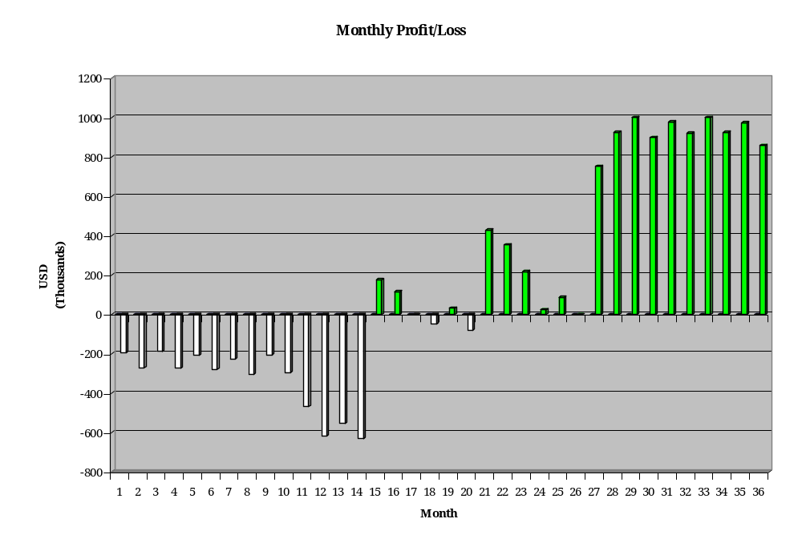
8.6 Projected Gross Margins
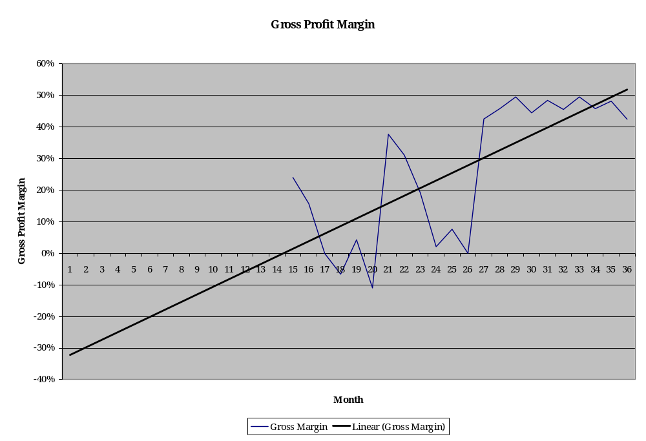
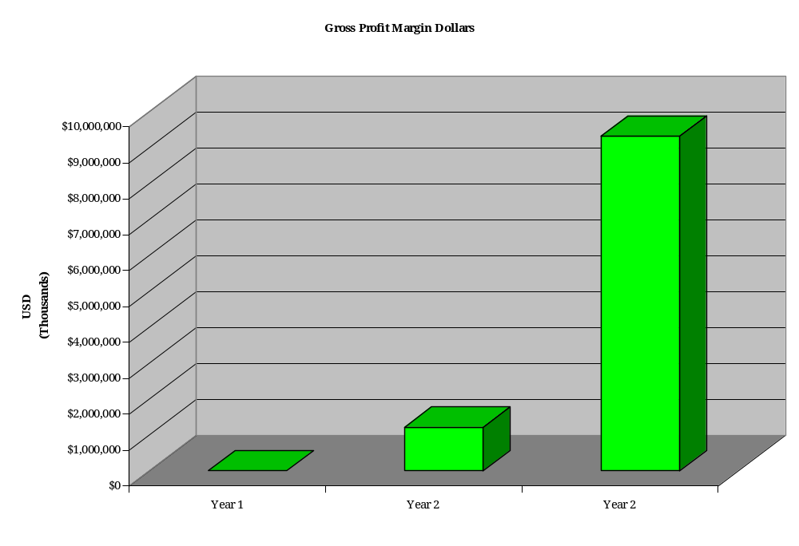
8.7 Projected Cash Flow
